**NOTE: It is fine that designing/ format/ output/ aesthetics of Your output can be different than exhibited below.**

Guidelines for the questions:

1. Use the saved Sample E-Commerce database
2. Prepare a table of Sales and Profit month-wise in one sheet, named it as ‘Working Sheet’. **Total Sales = Quantity *Sales**.  Methodology   
   1. Sumifs function across Months Variable for:
      1. Total Sales *(before that create a Total Sales = Sales*Quantity )*
      2. Profit
3. Prepare the sales table region-wise in the working sheet. Methodology
   1. Create using Sumifs formula with Region (in row) as grouping variable and Aggregation variables (in columns) as below:
      1. Sum of Total Sales
4. Create a User Control Combo box for Product Category.
   1. Refer to file *“3. Electronic - Combo boxes.xlsx”*
   2. Create combo box in new sheet called “Dashboard”
   3. Entire dashboard should be connected to combo box i.e. You select product Category and see all related numbers specific to selected product category
      1. Make minor changes in Q2 and Q3
5. Create Column Chart of a month-wise table (from table in Q2) and region-wise table (from table in Q3)
6. Link the table with combo box.    – Link table in Q2 and Q3 with combo box so that the values in table created in sheet ‘Working Sheet’ changes with value selected in combo box.

*Exception: Q1 i.e., Q1 is for overall data and not linked to combo box*

1. Create a dashboard. - populate below view in a tab named as “Dashboard”

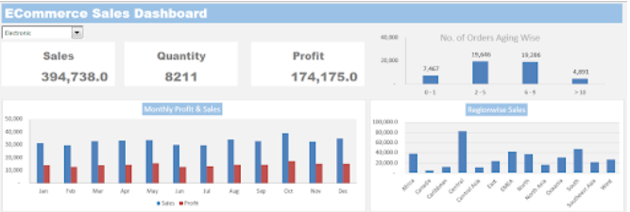

***Further Reference in continuation with above questions***

***Q2***

| **Months** | **Sum of Total Sales** | **Sum of Total Profit** |
| --- | --- | --- |
| Jan | ??? | ??? |
| Feb | ??? | ??? |
| Mar | ??? | ??? |
| Apr | ??? | ??? |
| May | ??? | ??? |
| June | ??? | ??? |
| July | ??? | ??? |
| Aug | ??? | ??? |
| Sep | ??? | ??? |
| Oct | ??? | ??? |
| Nov | ??? | ??? |
| Dec | ??? | ??? |

***Q3***

| **Region** | **Sum of Total Sales** |
| --- | --- |
| Oceania | ?? |
| Central | ?? |
| Central Asia | ?? |
| EMEA | ?? |
| North Asia | ?? |
| North | ?? |
| West | ?? |
| Africa | ?? |
| East | ?? |
| South | ?? |
| Southeast Asia | ?? |
| Caribbean | ?? |
| Canada | ?? |